Project Design Phase
Solution Architecture

Date | 29 June 2026
Team ID
Project Name | SHOPEZ-E-Commerce Application
Maximum Marks | 4 Marks

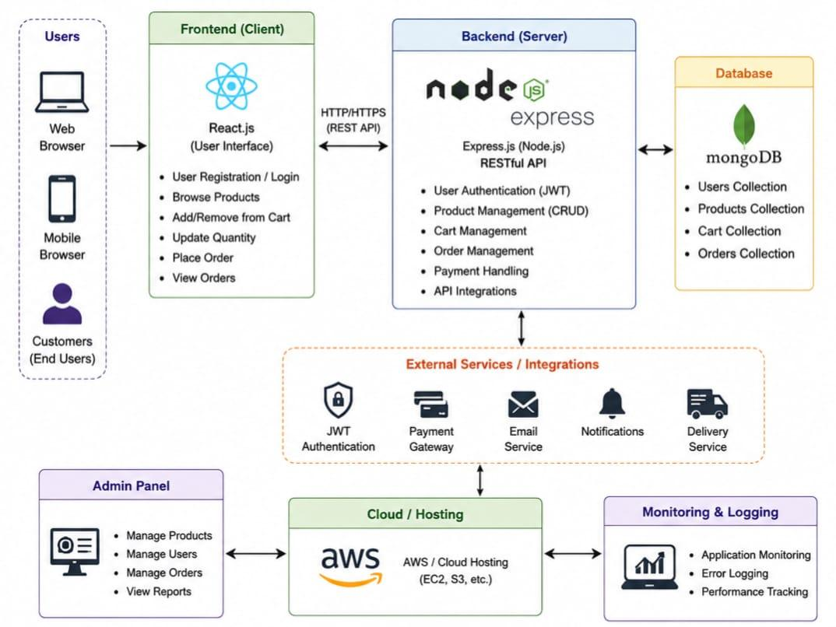

Figure 1: Solution Architecture and Data Flow of ShopEZ -E-Commerce Application

Solution Architecture Summary:

The ShopEZ E-Commerce Application follows a three-tier architecture consisting of a React.js frontend, a Node.js and Express.js backend, and a MongoDB database. The frontend communicates with the backend through REST APIs, while the backend manages authentication, product handling, cart operations, order management, and database interactions using Mongoose. This architecture ensures scalability, maintainability, and secure data handling.

